UNIT ONE: CARING FOR OUR WORLD

Lesson 1: The World We Live in.

Name: ______________________________ Date: ___________________

**Use the words in the box to name the continents on the map of the world.**

Africa Europe Asia South America

North America Australia Antarctica

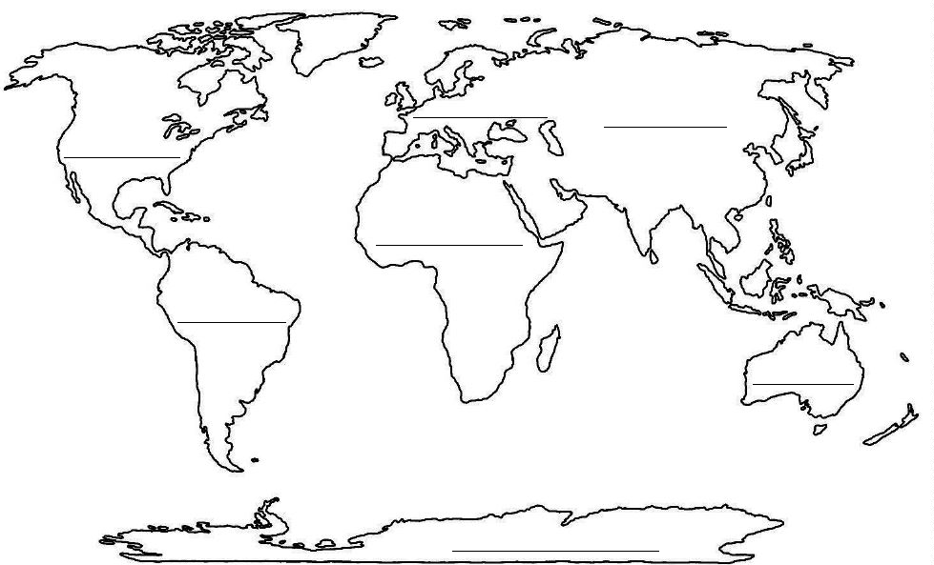

Name: ______________________________ Date: ___________________

1. **Put the words in the box where they belong in the chart below.**

huge cube see while mule

explore locate fume ski coat

ice twice more tune plane

cane maze wait cream stone

might folklore meat real cry

|  |  |  |  |  |
| --- | --- | --- | --- | --- |
| **Long /a/ as in take** | **Long /e/ as in be** | **Long /i/ as in try** | **Long /u/ as in tube** | **Long /o/ as in about** |
|  |  |  |  |  |
|  |  |  |  |  |
|  |  |  |  |  |
|  |  |  |  |  |
|  |  |  |  |  |

1. **You are flying above the continents. Write 5 sentences to tell what you can see. Use words from the chart.**

________________________________________________________________________

________________________________________________________________________

________________________________________________________________________

________________________________________________________________________

________________________________________________________________________

________________________________________________________________________

**“Another Hot Day on Jannah Beach”**

It was another hot day on the beach. Jihad was plying his trade selling ice cream to thirsty sunbathers. His box was nearly empty now and he was getting very tired. He thought he would walk down the beach where there weren’t many people. There he could rest a bit.

He spied a beach towel with no one on it. He figured that its owner might be swimming to cool off. He didn’t think it’s owner would mind if he sat on it for a little while. He would get off as soon as someone came near.

He thought to himself as he sat down: “What a weird looking towel, it looks more like a carpet.”

The towel started to flutter as if a breeze were picking it up. Jihad was frightened and jumped to his feet. It said: “I am a magic carpet. I was trying to get some sun and you came along.”

Jihad explained: “There is no such thing as a magic carpet. They only exist on stories.”

The carpet told him: “So this is a story, get on and I’ll show you. What is your desire?”

“I would like to see the world. I heard people talking about places like Africa, Asia, and Europe. Are those places real?” Jihad answered.

“Hop and I’ll show you the world,” promised the carpet. “Up, up, and awaaaay”.

He grabbed the edges of the carpet and they started to raise up into the sky, people now looked like dots and the sea appeared deep blue. “Sit back and relax. Enjoy the tour” the carpet told Jihad. The carpet zoomed forward and Jihad hung on to it.

“We are flying over Egypt, North Africa. It is famous for the Nile River and the pyramids.

Below to the right is Europe. It is famous for the mountain range called the Alps. Many people ski there in winter. Now, we are flying over the famous European country “France”, which is famous for the Eiffel Tower.

Now let’s go to America! To get to America, we have to go across the Atlantic Ocean. America us so big, so it has many places to see. There you have Niagara Falls, a tremendous waterfall between United States and Canada, and the Amazon River that looks like a huge snake twisting in the jungle down in South America.

Now let me show you where kangaroos live. Australia! There you can also find a lot of famous places like: Sydney Harbor and the Ayres Rock. To get to Australia, we will have to go across the Pacific Ocean. Look at it! It looks like a big island, but it is a continent.

Finally, Asia. Asia is another fascinating continent. It is famous for the Himalayas, a mountain range with the highest peak in the world. It is also famous for the Great Wall of China, a wall built by a Chinese emperor long time ago. Now we’re going back to where we started.”

Jihad said excitedly, “This trip was out of this world! The world is too big and I want to know more about it. Thank you!

Name: ______________________________ Date: ___________________

**Read the story “Another Hot Day on Jannah Beach”. Fill in the following chart.**

Title of the story: ____________________________________________________________

___________________________________________________________________________

Characters: _________________________________________________________________

___________________________________________________________________________

Place: _____________________________________________________________________

___________________________________________________________________________

Main Event: ________________________________________________________________

___________________________________________________________________________

Details: ____________________________________________________________________

___________________________________________________________________________

___________________________________________________________________________

___________________________________________________________________________

___________________________________________________________________________

Conclusion: ___________________________________________________________________________

___________________________________________________________________________

___________________________________________________________________________

___________________________________________________________________________

Name: ______________________________ Date: ___________________

**Read the story “Another Hot Day on Jannah Beach”. Complete the chart with facts about each continent.**

|  |  |  |  |  |
| --- | --- | --- | --- | --- |
| **Africa** | **Europe** | **America** | **Australia** | **Asia** |
| *The Nile River* |  |  |  |  |
|  |  |  |  |  |

Name: ______________________________ Date: ___________________

1. **Read the verbs in the box. Use each verb in a sentence to complete what Jihad and the carpet did.**

explain jump grab spy sit talk

ply my trade zoom relax flutter promise

*I________________________________________________________________________________________________________________________________________________________________________________________________________________________________________________________________________________________________________*

*I________________________________________________________________________________________________________________________________________________________________________________________________________________________________________________________________________________________________________*

1. **Do you think the actions of the carpet are real or fantasy? Why?**

**________________________________________________________________________________________________________________________________________________________________________________________________________________________________________________________________________________________________**